## Selenium WebDriver

# Homework

Go to <https://www.telerik.com/> and log in.

* Record a test to Edit your Profile. Fill the form as shown below, leave Company Name blank. Verify that a message about missing Company name appears.

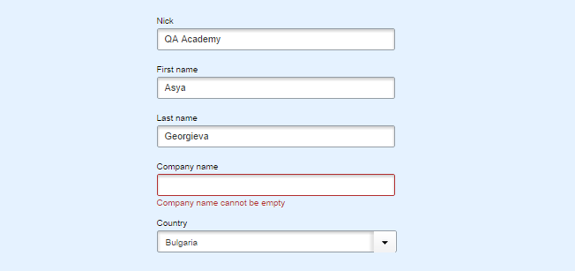

* Now fill in Company name using C# function, use unique name every time. Verify the message isn’t present anymore.
* Test if the backend validation works properly. For that you’ll have to disable JavaScript in your test and then start editing. Run the test a couple of times to verify that it works correctly. You can try to delete a login cookie.